**J**APAN

**M**ARROW

**D**ONOR

**P**ROGRAM

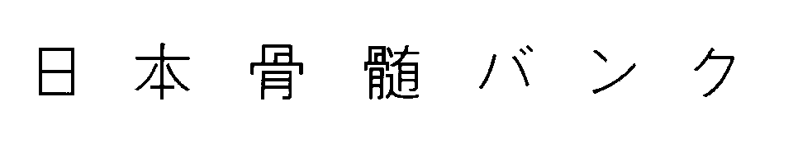

*Hirose 2nd Bldg., 7F. 3-19 Kandanishiki-cho,*

*Chiyoda-ku, Tokyo 101-0054 JAPAN*

*Phone: +81-3-5280-4771 Fax: +81-3-5280-3856*

SEARCH REQUEST

|  |  |
| --- | --- |
| **Date of Request:**  _______ / _______ / _______  　　　　　　　　　　 month day 　 year | **Is this search urgent?**  Yes  No |

|  |  |  |
| --- | --- | --- |
| **Last name:** | **First Name:** | **Date of Birth:**  ________ / ________ / ________  month day year |
| **Blood Type:** | **Sex:**  Male  Female | **CMV Status:**  Positive  Negative  Unknown |
|
| **Race:** | **Weight:**  kg | **Height:**  cm |
| **Diagnosis:** | **Current status:** | **Date of Diagnosis**:  ______ / ______  month year |
|

**Patient Class I typing results:**

|  |  |  |  |
| --- | --- | --- | --- |
|  | **A** | **B** | **C** |
| **First value:** |  |  |  |
| **Second value:** |  |  |  |
| **Testing method:** | **Sero.  DNA** | **Sero.  DNA** | **Sero.  DNA** |

**Patient Class II typing results:**

|  |  |  |  |  |
| --- | --- | --- | --- | --- |
|  | **DRB1** | **DRB3/4/5** | **DQB1** | **DPB1** |
| **First value:** |  |  |  |  |
| **Second value:** |  |  |  |  |
| **Testing method:** | **Sero.  DNA** | **Sero.  DNA** | **Sero.  DNA** | **Sero.  DNA** |

|  |
| --- |
| **Are haplotypes identified?  Yes  No** |

|  |
| --- |
| **Transplant Center:** |
| **Requesting Physician:** |

**JMDP Search Coordinator:**Dec. 2024